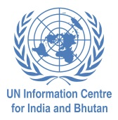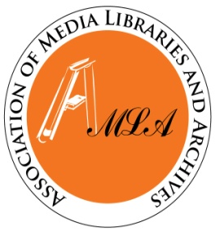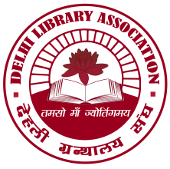

Seminar on
Youth and Sustainable Development:
Role of Media, Knowledge Networks and Libraries

at UN Conference Hall, 55 Lodi Estate, New Delhi, on 11 August 2015

Registration Form

Prof./Dr./Mr./Ms..................................................................................................................

Designation...........................................................................................................................

Organization.........................................................................................................................

Mailing Address...................................................................................................................

................................................................................................................................................

Phone/Fax.............................................................................................................................

E-mail....................................................................................................................................

Date..................... (Signature)

NB: Registration is FREE

Participants from outside Delhi are expected to get a sponsorship from their parent organizations or make their own arrangements for travel and accommodation. However, on 11 August 2015 in Delhi, the organizers will provide lunch, refreshments, etc., during the Seminar. We can, if requested, assist participants in making hotel reservations.
The completed registration form must reach us latest by 3 August 2015 via e-mail at r.k.sharma@unic.org or at the following address:
Dr. R.K. Sharma
Librarian
United Nations Information Centre for India & Bhutan
55 Lodi Estate, New Delhi – 110 003
Tele +91-11-46532236
Fax : +91-11-24620293

